As You Law It.
Negotiating Shakespeare

WEDNESDAY 9 NOVEMBER 2016

9.30 Welcoming addressES
Nicola Sartor, Magnifico Rettore dell’Università degli Studi di Verona
Roberta Facchinetti, Direttore del Dipartimento di Lingue e Letterature Straniere
Donata Gottardi, Direttore del Dipartimento di Scienze Giuridiche
Daniela Carpi, Presidente AIDEL

CHAIR: Daniela Carpi (University of Verona)

10.00 Jeanne Gaakeer (Erasmus University Rotterdam):
The Struggle for (the) Law: German Legal Theorists on Shakespeare
10.30 Pier Giuseppe Monateri (University of Turin):
The Lawyer’s Skull. Hamlet and His Knowledge of the Terminology of Law

11.00 COFFEE BREAK

11.30 Heinz Antor (University of Cologne):
Race, Ethnicity, and the Law in William Shakespeare's The Merchant of Venice
12.00 Andrew Majeske (John Jay College of Criminal Justice, New York):
The Poems & Riddles of As You Like It 3.2: Relativism, Historicism, and the Shaky Foundations of Post-Post Modernity

12.30 Discussion

13.00 - 14.30 LUNCH

CHAIR: Pier Giuseppe Monateri (University of Turin)

14.30 William McNeil (Southern Cross University):
As You Love It/Law It/Lack It: Shakespeare's Sexual and Social Contract(s) in As You Like It
15.00 Daniela Carpi (University of Verona):
King John or the Proliferation of the Word of Authority
15.30 Regina Schwartz (Northwestern University): Rebuke and Revenge: Hamlet Revisited
16.00 Marett Leiboff (University of Wollongong):
‘Stir Up the Australian Youth to Merriment’: A Midsummer Night's Dream and the Theatrical Transmutability of Law's Texts

16.30 Discussion

17.00 COFFEE BREAK

17.30 Gary Watt: Performing Shakespeare.
Francesca Lorenzetti, violinist.

20.00 CONFERENCE DINNER

THURSDAY 10 NOVEMBER 2016

CHAIR: Chiara Battisti (University of Verona)

9.30 Gary Watt (University of Warwick):
Just in Time: A Rhetorical Amplification of A Strange Eventful History
10.00 Paul Raffield (University of Warwick): Shakespeare's Twin Brother
10.30 Tommaso Dalla Massara and Carlo Pelloso (University of Verona):
Caesar: Inside and Beyond the Law

11.00 COFFEE BREAK

11.30 Steven Howe (University of Luzern): Shakespearean Negotiations: The Merchant of Venice and Nazi Legal Culture
12.00 Cristina Costantini (University of Perugia):
Shaking the Law. The Sceptered Sway Transfixed

12.30 Discussion

13.00 - 14.30 LUNCH

14.30 - 15.00 AIDEL ANNUAL MEETING

CHAIR: Yvonne Bezrucka (University of Verona)

15.00 François Ost (Université Saint Louis, Bruxelles): Mesure pour mesure. Le droit pénal est-il fait pour être appliqué?
15.30 Daniel Gervais (Academia Europaea):
Measure for Measure: Literary Property in the Time of William Shakespeare

16.00 COFFEE BREAK

16.30 Chiara Battisti (University of Verona): Shakespeare and the Politics of Citizenship. Desire, Migration, and Pathology in Othello
17.00 Isabella Zambotto (University of Rome-Tor Vergata):
Caesar's Portrait: A Historical and Legal Paradigm

17.30 Discussion

FRIDAY 11 NOVEMBER 2016

CHAIR: Yvonne Bezrucka (University of Verona)

9.30 Giovanni Iudica (Bocconi University, Milano): Loans, Interests, Usury
10.00 Filippo Sgubbi (University of Bologna):
Measure in Penal Law

10.30 COFFEE BREAK

11.00 Sidia Fiorato (University of Verona):
Richard III and the Performance of Sovereignty

11.30 Gilad Benun (Global & European Studies Institute, Universität Leipzig):
International Law and Arcana Imperii (‘Mystery of State’) in Henry V: Christopher Marlowe as the Bearer of Political Influences upon Shakespeare

12.00 Discussion

12.30 LUNCH

Scientific committee
Daniela Carpi
Chiara Battisti
Sidia Fiorato

Organizing committee
Valentina Adami
Raffaele Cutolo
Anja Meyer

Roberta Zanoni

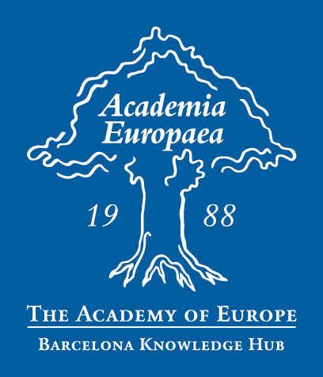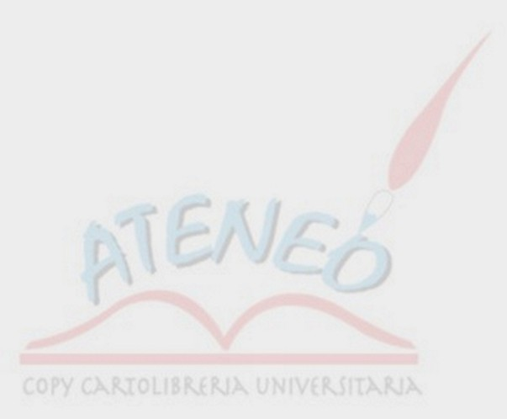


Con il patrocinio di



Dipartimento di Scienze Giuridiche

As You Law It
Negotiating Shakespeare

International Conference

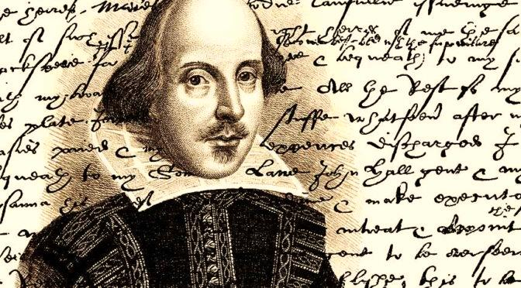

9-11 November 2016

verona
Museo Civico di Storia Naturale
Lungadige Porta Vittoria 9

